**DATA ANALYTICS FOR HEALTH CARE**

**TEAM ID: PNT2022TMID04319**

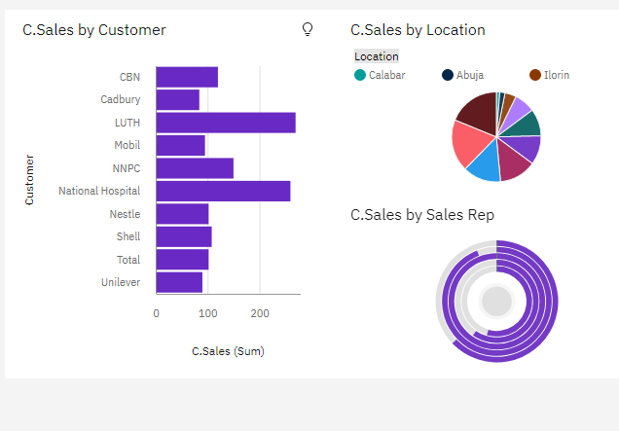

<https://us3.ca.analytics.ibm.com/bi/?perspective=dashboard&pathRef=.my_folders%2Fassessment%2B2%2Fa1&action=view&mode=dashboard&subView=model000001837f4a52d7_00000002>

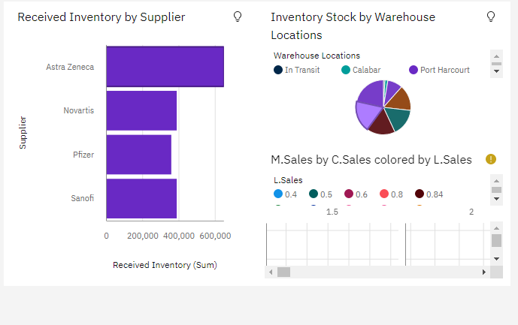

<https://us3.ca.analytics.ibm.com/bi/?perspective=dashboard&pathRef=.my_folders%2Fassessment%2B2%2Fa1&action=view&mode=dashboard&subView=model000001837f5efbf2_00000000>

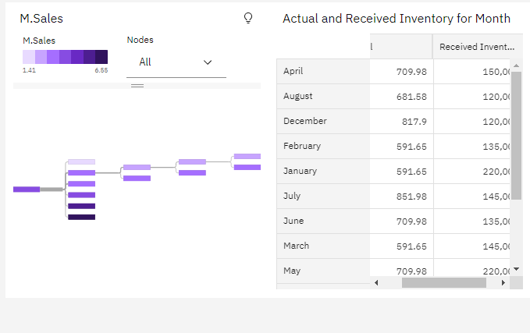

<https://us3.ca.analytics.ibm.com/bi/?perspective=dashboard&pathRef=.my_folders%2Fassessment%2B2%2Fa1&action=view&mode=dashboard&subView=model000001837f6ddc91_00000000>